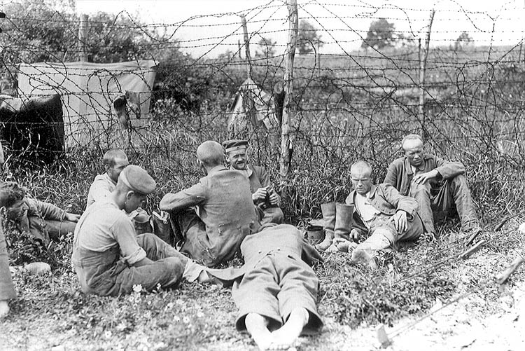
Essential Questions: World Literature Unit.
Guiding Questions:
*How do I relate to the works of "Imprisoned Lives": Primo Levi’s Survival in Auschwitz; Franz Kafka’s Metamorphosis and Albert Camus’ The Stranger?

Over arching Questions:
*What impact does a Christian World view have on imprisoned lives?

Topical Questions:
*How does translation affect the ground motif of a novel?
*How do translated works enhance or impair communication?
*What effect does the translation of the work affect message of the novel?
*How does the language and culture of the work impact translation thereof?

