4. How can the different ways of knowing help us to distinguish between something that is true and something that is believed to be true?

Luigi Pirandello stated “A fact is like a sack which won't stand up when it is empty. In order that it may stand up, one has to put into it the reason and sentiment which have caused it to exist.” After understanding the value of each way of knowing, such as logic, emotion, language, and sense perception, I realized that different ways of knowing are deeply related to the method of discovering truth. Although some of the ways of knowing might have greater strengths or weaknesses which provide a different depth of knowledge, these help to distinguish something that is true and something that is believed to be true because they are all interconnected. The definition of truth or something that is believed to be true; is not sufficient to understand how people attribute truth; rather it is essential to examine our ways of knowing through the use of examples and experiences that help one to establish the concept of truth. I have experienced innumerable people arguing and debating about whether something is true or not. This raises the question “how can we know the truth? Is there enough evidence to substantiate the claim?”In regards to this question, this essay will explore the different ways of knowing that reveal how to find truth.

So what is the difference between something that is true and something that is believed to be true? According to my Nature of Truth presentation, philosopher David Hume states truth itself is relative. He claims “reason is the only way to discover truth and to find reason discovery of ideas should conform to real existence.” This echoes the correspondence theory about which we have learnt; that what one individual sees and believes should match in order to become true. For example, if one sees and believes a single desk to have a rectangular shape and legs made of metal, it is considered a truth, but this is a fallacy. Some desks are made up of circular shapes and have legs with different elements. Thus Hume proposes that there is never an absolute truth. Similarly, Hume’s friend Jean Jacques Rousseau avows “there is no innate knowledge, we have to find reason using our tendency of love. But to establish truth there needs to be reason with compassion which is nearly impossible.” Thus many philosophers considered logic as a powerful way to approach truth.

Let’s consider the fact that all Theory of Knowledge students have to write 700 word responses. How do we know this is true? By using deductive reasoning, which is limiting a scope down from the general to the particular it becomes a valid statement “All TOK students have to write 700 word responses” “Robin is in TOK class” “therefore Robin has to write a 700 word response.” This logic is considered the most infallible way of knowing because we use it every day and it provides certainty.

However, other than logic there are many ways of knowing that help us to differentiate between truth and something believed to be true. Emotion is one of them. Emotion is a “normal judgment” that can be distinguished between the instinctive and social emotions, and between the inward-looking emotions and outward-looking emotions. The first method, which is instinctive and social emotions, stresses the origins of emotions; love or shame, while the second way, inward and outward looking emotions asks about the nature of our experience; fear or wonder. Inside these emotions there are feelings called intuition that are a part of instinctive emotion, which is to gain knowledge without reasoning. In my personal life, I have a friend who is always late for a meeting. Therefore I leave 30 minutes later assuming that my friend will arrive late too. And as predicted, my friend arrives later than the appointed time. Although, I correctly predict that my friend will arrive late, it is what I believe to be true. In order to guess my friend will be late, I have had to have prior knowledge and experience of my friend and his behavior, which results in unconscious empiricism. This becomes a flaw because empiricism is based on a thought belief rather than a scientific experiment. It means empiricism is just an idea or theory which is actually not visible or tangible?

According to J-P Sartre, “words are more powerful and treacherous than we think.” Language is another way of knowing similar to emotion. So it helps us know what is believed to be true, because the words or meanings are flexible; it is used to inform, direct, and express our thought. For example, language can help the communication between handicapped and people who are not handicapped. Sign language is one of the ways of knowing. By using visually transmitted sign patterns, it mainly helps people to convey message to the deaf or hearing impaired.

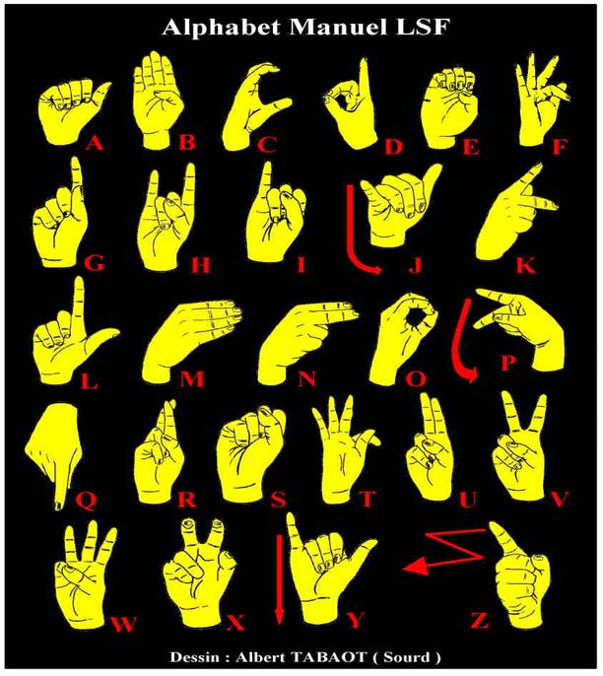
http://library.thinkquest.org/05aug/01046/images/use/asl_clip_image002.jpg

But there are not many people who understand sign language. There are certain people who can comprehend sign language because it requires education of general acceptance, agreed upon by the community. So it involves sense perception, which enables our brain to comprehend, understand, and guide us in our quest for truth. After we sense something or become conscious of the world, we begin to filter the senses in our brain and sort out truth and what is believed to be true. For instance, when blindfolded students are asked to drink coke and then sprite as an experiment, majority of them were able to tell the difference between the different drinks. And we as a research group were able to use accurate and consistent data to measure their responses.

As a result, something that is believed to be true can easily be distinguished by ways of knowing because truth requires an objective stance. While something that is believed to be true is a subjective matter, such as, whether the existence of God is true, to most Jews or Christians but this is considered as personal faith. It’s because spirituality cannot be explained empirically. Nobody can test if God exists even though humans fervently attempt to find God.

In hind sight, different ways of knowing can obstruct absolute truth. For example, the taste bud map which was proposed to be true in 19th century lasted only for a century and is now considered false. This means something that is already true can be proven false at anytime. This theory was proven false because of sensory perception, which is one way of knowing illustrated above. Originally, the tongue map shows that different parts of the tongue containing taste buds and can sense four different characteristics which are sweet, salty, sour and bitter. But when scientist actually performed an experiment, there was no specific part that sensed a different taste.

These ways of knowing sometimes hinder the process of exploring truth. Thus there are limitations to each different way of knowing. Logic sometimes is inaccurate because people make hasty generalizations based on deficient or insufficient evidence. For language, the words can only be believed to be true, to a certain extent because the actual meaning can be lost during the translation. Also when we take away one or more of the senses from the each individual, accuracy falls drastically. Lastly for emotion, the limitation is that it is motivated interpretation rather than fact and is considered a value judgment.

Despite these limitations, all four ways of knowing in any sense helps distinguish between something that is true and something that is believed to be true. Logic, sense perception, emotion, and language, all assist refuting originally accepted truth. Now, even at this moment of writing a Theory of Knowledge essay, four ways of knowing help me justify which part is true and which is uncertain. I should appreciate this nature of my knowledge and continually develop understanding of the different ways of knowing.

Word Count: 1426

Bibliography

Wanjek, Christopher . "Live Science." The Tongue Map: Tasteless Myth Debunked. Available from http://www.livescience.com/health/060829_bad_tongue.html. Internet; accessed 3 December 2009.

Thomas, Brian. "Empiricism: A Glaring Flaw of New Atheism ." INSTITUTE FOR CREATIVE RESEARCH. Available from http://www.icr.org/article/empiricism-glaring-flaw-new-atheism/. Internet; accessed 3 December 2009.

"Ways of Knowing." Problems of Knowing and the Linking Questions. Available from http://www.amyscott.com/WAYS%20OF%20KNOWING%20LInking.pdf. Internet; accessed 3 December 2009.

Taken from my TOK presentation at Taejon Christian International School, delivered 27 Feb 2009.
Taken from my previous TOK essay “Is it oversimplification to claim that some Ways of Knowing give us facts while others provide interpretations?”
Thomas, Brian. "Empiricism: A Glaring Flaw of New Atheism ." INSTITUTE FOR CREATIVE RESEARCH. Available from http://www.icr.org/article/empiricism-glaring-flaw-new-atheism/. Internet; accessed 3 December 2009.
"Ways of Knowing." Problems of Knowing and the Linking Questions. Available from http://www.amyscott.com/WAYS%20OF%20KNOWING%20LInking.pdf. Internet; accessed 3 December 2009.
Wanjek, Christopher . "Live Science." The Tongue Map: Tasteless Myth Debunked. Available from http://www.livescience.com/health/060829_bad_tongue.html. Internet; accessed 3 December 2009.

